***SUBJECT:******Australian Noise Exposure Forecast Map Update for LEP***

***RESPONSIBLE OFFICER:*** ***Strategic Planning Undergraduate - Olivia Lewis-Curnoe***

***Strategic Planning Manager - Martin Johnson***

*Do not delete this line*

|  |
| --- |
| ***SUMMARY***  The purpose of the Summary section is to provide a brief summary on the reason for preparing the Report. Should be limited to one paragraph.  The Australian Noise Exposure Forecast is mapped in Cessnock Local Environmental Plan 2011. It informs land use planning decisions.  A report commissioned by Council reassessing the Australian Noise Exposure Forecast mapping for Cessnock Aerodrome has been prepared. This report found that there had been changes in the noise exposure area.  This report seeks Council’s endorsement of a Planning Proposal to amend the Australian Noise Exposure Forecast mapping in Cessnock Local Environmental Plan 2011. |

*Do not delete this line*

|  |
| --- |
| ***RECOMMENDATION***  The purpose of the Recommendation section is to request a decision after reading the  report. This recommendation is very important as the author requests the reader to follow their recommendation based on the information provided to them in the report.   1. **That Council request a Gateway Determination for the Australian Noise Exposure Forecast Planning Proposal from the Department of the Planning and Environment pursuant to Section 3.34 of the *Environmental Planning and Assessment Act, 1979;*** 2. **That Council request authorisation under Section 3.31 of the *Environmental Planning and Assessment Act, 1979* to act as the local plan-making authority to make the Local Environmental Plan;** 3. **That Council undertake consultation with public authorities and the community as conditioned by the Department of Planning and Environment’s Gateway determination; and** 4. **That Council receive a further report following community consultation of the Planning Proposal.** |

*Do not delete this line*

***BACKGROUND***

The Background section provides the history of the issue. Provides the reader with information relating to past involvement in the issue and puts the current report in context.

An Australian Noise Exposure Forecast (ANEF) map shows the predicted cumulative exposure to aircraft noise for land near aerodromes or airports.

The ANEF assists in understanding how compatible different types of land uses are with the operation of the aerodrome or airport. Equivalent ANEF values at individual positions around the aerodrome are combined on a map to form ANEF contours. These contours are then used to identify site suitability for different types of land uses.

The Cessnock Aerodrome ANEF is mapped within Cessnock Local Environmental Plan 2011 (CLEP 2011), and relied on by Clause 7.5 “Development in areas subject to airport noise”.

Clause 7.5 outlines the need for the consent authority to assess whether development of land covered by ANEF mapping will be impacted by the noise of the aerodrome operation by using the contour measurements provided on the map.

***REPORT/PROPOSAL***

The Report section is the body of the report and discusses the issue at hand. The author should provide the reader with as much information as possible on the issue being debated, in order to make an informed decision on the matter.

ANEF mapping requires regular updates to account for changes in movements (time and frequency), circuits and aircraft types using the aerodrome.

The Cessnock Aerodrome ANEF map was last updated in August 2013. Since this time, there have been changes to the airport circuits, which have necessitated a review of the ANEF.

A review of the current ANEF contours has been undertaken by Global Airspace Solutions as contained within the Planning Proposal at ***Enclosure 1***.

The review has found that the ANEF from August 2013 (***Figure 1***) has altered. Under the current operational conditions, the intensity of noise is lower, however it covers a wider area (***Figure 2***).

To better inform land use planning decisions in and around the aerodrome, the current ANEF map within CLEP 2011 should be updated. Changing the mapping does not change the level of noise at the aerodrome - it merely reflects the current patterns already being experienced.

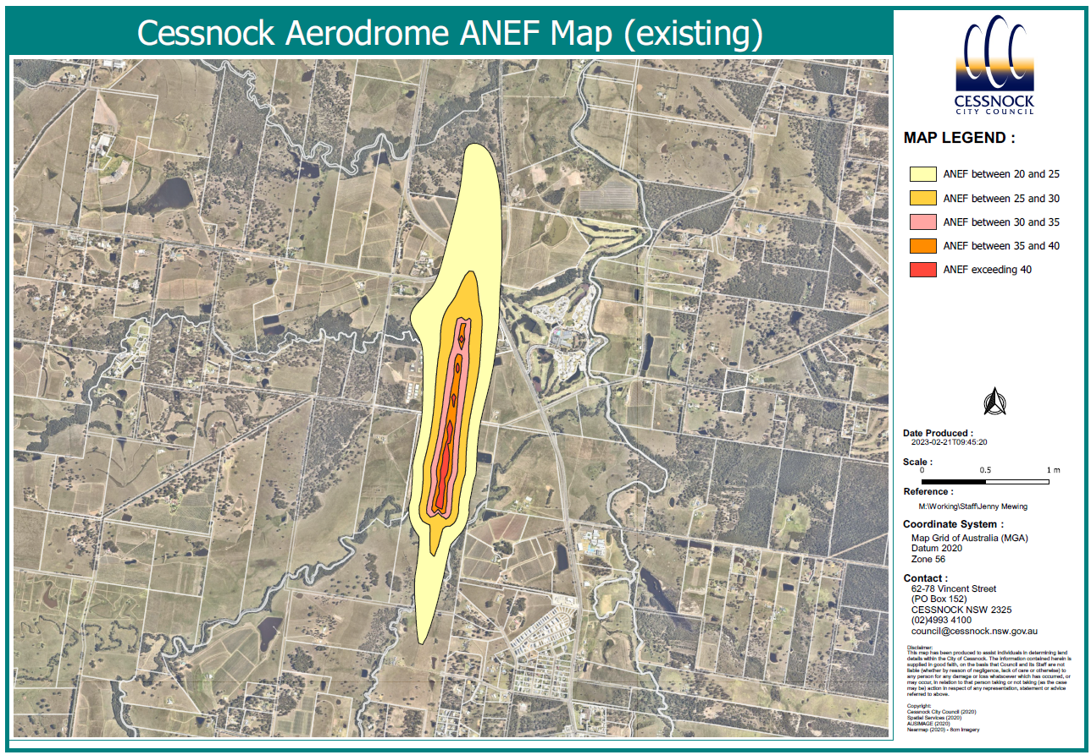

***Figure 1. Current ANEF map***

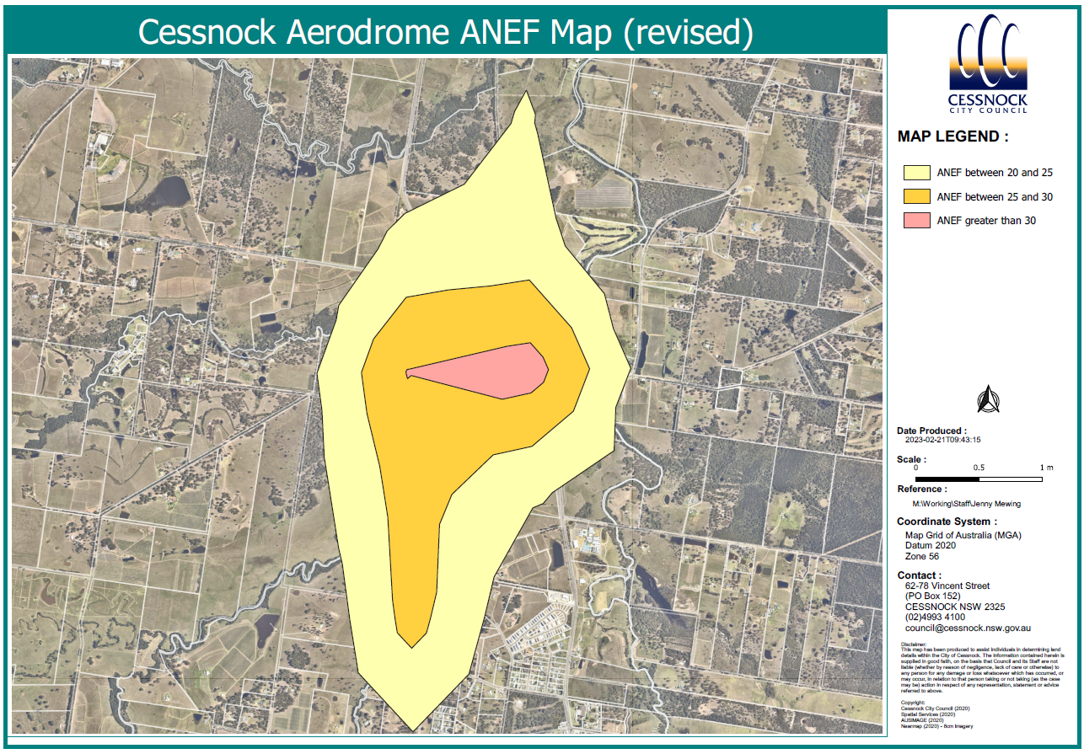

***Figure 2. Revised ANEF Contours***

***CONSULTATION***

The Consultation Section is to provide a listing of who has been consulted when writing the report. This could cover internal or external parties and/or both.

The ANEF revisions were commission by Council’s Works and Operations Unit who have been consulted in relation to the amendments to CLEP 2011.

The Planning Proposal will be publicly exhibited in accordance with the conditions of a Gateway determination and Council’s Community Participation Plan.

***STRATEGIC LINKS***

1. Delivery Program

Any links to the Delivery Program are detailed here. A recommendation will not be supported unless it directly progresses an activity in the Council Management Plan. NIL if no links. N/A if not applicable.

The Planning Proposal is consistent with the following themes and objectives of the Cessnock 2036 Community Strategic Plan (CSP):

* Outcome 2: A sustainable and prosperous economy
* Outcome 4: Accessible infrastructure, services, and facilities

1. Other Plans

Any links to other Strategic documents are detailed here. NIL if no links. N/A if not applicable.

Objectives 7, 8 and 9 of the Hunter Regional Plan 2041 (HRP 2041) are relevant to the Planning Proposal.

The relevant strategies for Planning Proposals under these objectives relate to protection of sensitive land uses from air pollution, facilitation of active tourism and protection of land near viticultural land to provide suitable separation distances for sensitive uses.

Updating the ANEF mapping will enable better planning decisions in the surrounding area having regard for more accurate impacts from the operation of the aerodrome.

The Planning Proposal is consistent with the Local Strategic Planning Statement as it ensures delivery of a planning framework that protects the interests of infrastructure land, as well as protecting sensitive land uses from incompatible development.

***IMPLICATIONS***

1. Policy and Procedural Implications

This section details any policies or procedures relevant to the report. The author must address any implications relating to Council policies or procedures. NIL if no implications. N/A if not applicable.

Nil

1. Financial Implications

This section details any financial issues that need to be considered. The author provides the reader with funding sources and whether the funding is budgeted. NIL if no implications. N/A if not applicable.

Nil

1. Legislative Implications

The author discusses any legislative references or implications in this section. This should detail relevant sections of Acts and/or Regulations. NIL if no implications. N/A if not applicable.

Development within the mapped ANEF area must have regard for Clause 7.5 of the CLEP 2011.

Council is responsible for issuing Planning Certificates which provide information on matters relating to land. ANEF mapping is utilised for informing notations on the S.10.7(5) Certificates. Amendment of the mapping will ensure greater accuracy of these certificates for land affected by aircraft noise.

1. Risk Implications

The author discusses any risk issues in this section. NIL if no implications. N/A if not applicable.

Nil

1. Environmental Implications

The author discusses any other implications. Implications may be environmental, community/social, consultative and/or insurance.

The current ANEF mapping does not accurately reflect the noise affectation of the aerodrome operation. Updating the mapping in the CLEP 2011 will provide better guidance for making land use planning decisions in the vicinity of the aerodrome in relation to aircraft noise. It will not increase levels of aircraft noise.

1. Other Implications

The author discusses any other implications. Implications may be environmental, community/social, consultative and/or insurance.

Nil

# *CONCLUSION*

This section provides a wrap-up of the issues raised in the report. No new information should be introduced here. Should lead to the reasons for recommendations.

The existing ANEF mapping does not accurately reflect current operational conditions of Cessnock Aerodrome.

Updating the data allows the map to reflect the current and future use of the airport, which ensures accurate data is used for planning surrounding the airport.

It is recommended that the enclosed Planning Proposal be forwarded to the Department of Planning and Environment for a Gateway Determination to amend CLEP 2011.

*Do not delete this line*

***ENCLOSURES***

|  |  |  |
| --- | --- | --- |
| **[1](O:\\TEMPORARY\\InfoCouncil Enclosures\\01 - Ordinary Council Meeting\\2023\\02 - 15 March 2023\\Planning Proposal Cessnock Aerodrome ANEF _ Enclosure 1 _ Planning Proposal.pdf)** | Planning Proposal - Cessnock Aerodrome ANEF Map Amendment |  |